

command to check disk space : df -h

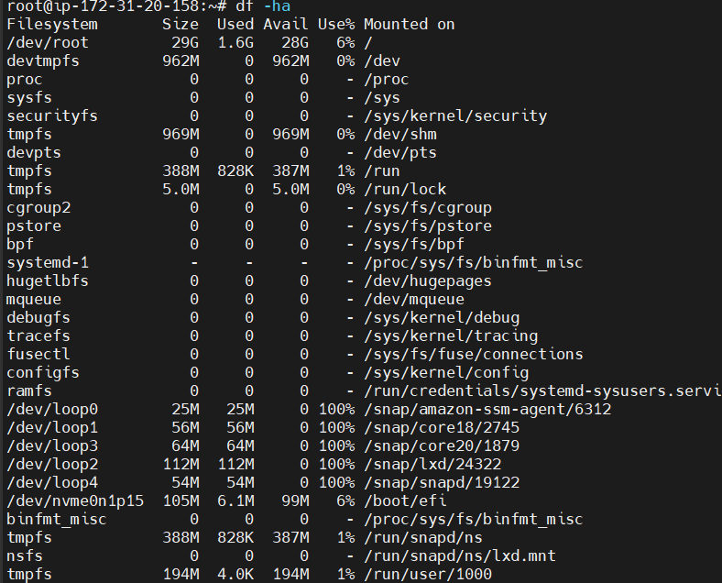

command check memeory : free -h

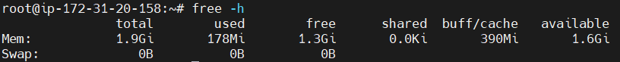

Command to check disk usage : du -h

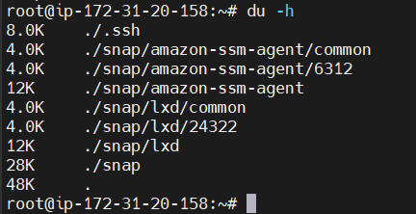

Command to check file system : df -T

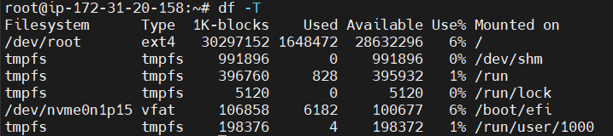

command to check processor : lscpu

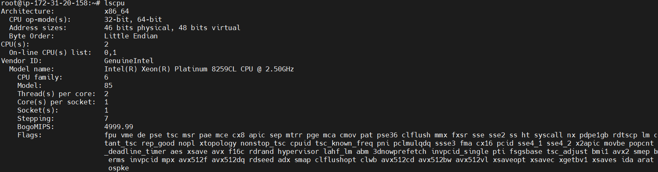

Command to check top running process : top

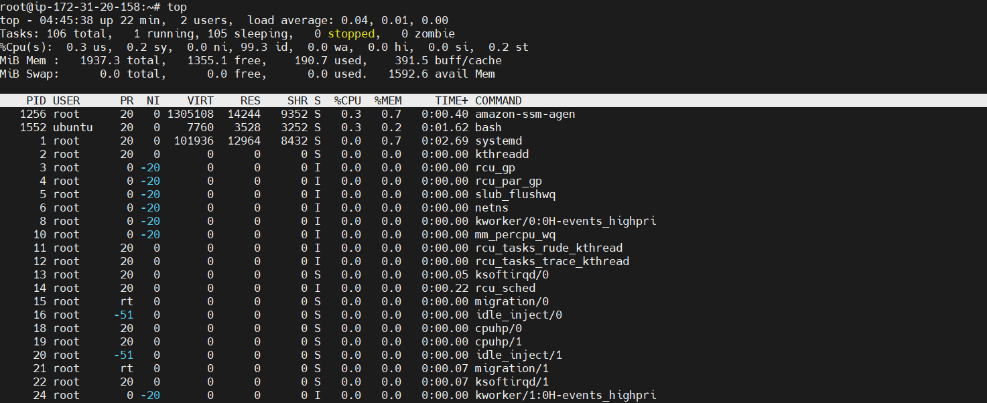

copy file from one machine to another machine :

command to check running ports : lsof -i \*another one \*netstat -nutlp

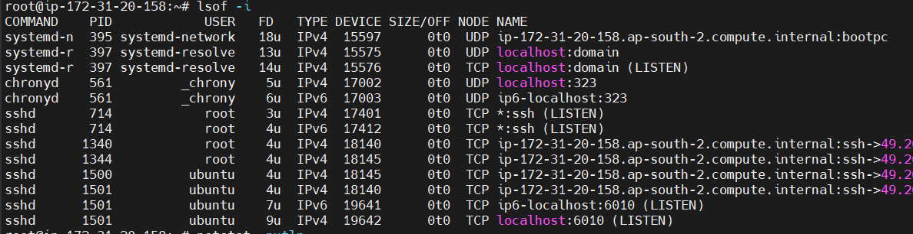

command to check open ports : ss -tunl

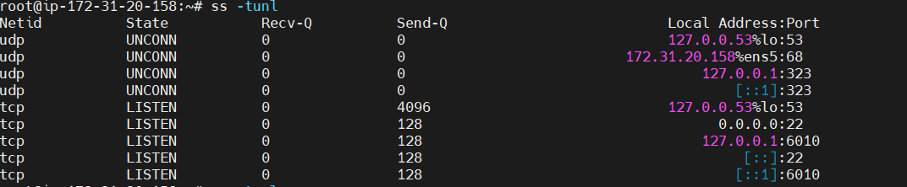

Command to check used process : ps aux

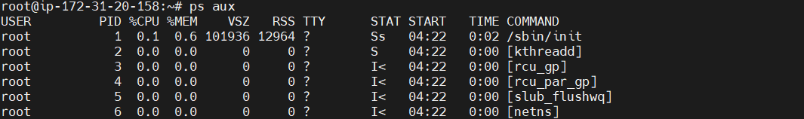

Command find a specific file in linux : find / -name <file> \*directory for file use find -name <file>



explain booting process : Power on -> BIOS / UEFI initialization -> boot loader -> kernel initialization -> init process -> system initialization -> Login manager -> user session

how to change ownership permission : chown <usergroup> <user name>

how to change file permission : chmod

how will you create a user in linux : sudo adduser -> user name -> user details etc

how will you add user in group : usemod -aG <group name> <user name>

how will you check what are the packages installed in machine : dpkg –l

command file and replace -sed : sed -i ‘s/<actual name>/<replacename>/G’s <vi file name>

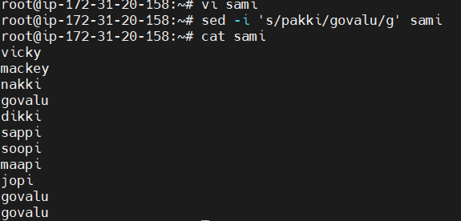

how will you create a hardlink and softlink :

Soft : ln -s <filename> <link name>

Hard : ln <filename> <link name>

what is the command to restart the service, without downtime .service :

what is LVM : LVM stands for Logical Volume Manager. It is a software component used in Linux-based operating systems to manage disk storage at a higher level of abstraction. LVM allows for the creation and management of logical volumes, which are virtual partitions that can span across multiple physical disks or disk partitions.

how will you make password less authentication login in linux :